Importing IFSP Reviews in the Database
February 19, 2018
Revised

Guidance Document
- A Guidance Document, Tips for Entering IFSP Reviews in the Database, will be posted to the KDHE website. (02/20/18)
- The guidance document and this presentation will show both the IFSP User screens and the Admin/Data Manager user screens.

Objectives
- Show Steps to add an IFSP review from the IFSP users side of the database.
- Show Steps to add an IFSP review from the Admin / Data manager user side of the database.
- Review of current guidance regarding practices.

Background
- An IFSP Review must be conducted at least every six months.
- An IFSP Review consists of adding the 3 pages marked IFSP Review to either an Initial or Annual IFSP
- An IFSP Review does not “stand alone”.
- Reviews must be documented, either throughout the IFSP or on the Review Summary Page.
- In an IFSP review, all pages of the IFSP could be updated.
    - For example: vision or hearing screening, updated information, or a new hospitalization could be added.
- If updated information is not added to the IFSP page, then it must be noted on the Review Summary page.
- A FSC can conduct the review meeting with the family alone, however a review could include other providers as necessary.
- To view a child’s service history:
  - The IFSP user can only see the history by opening each individual IFSP in the child’s IFSP/ECO tab and viewing the services.
  - An admin/data manager user can view the history of services by going to the Services tab on the database side.

Documentation of IFSP team Involvement

- Actually at meeting
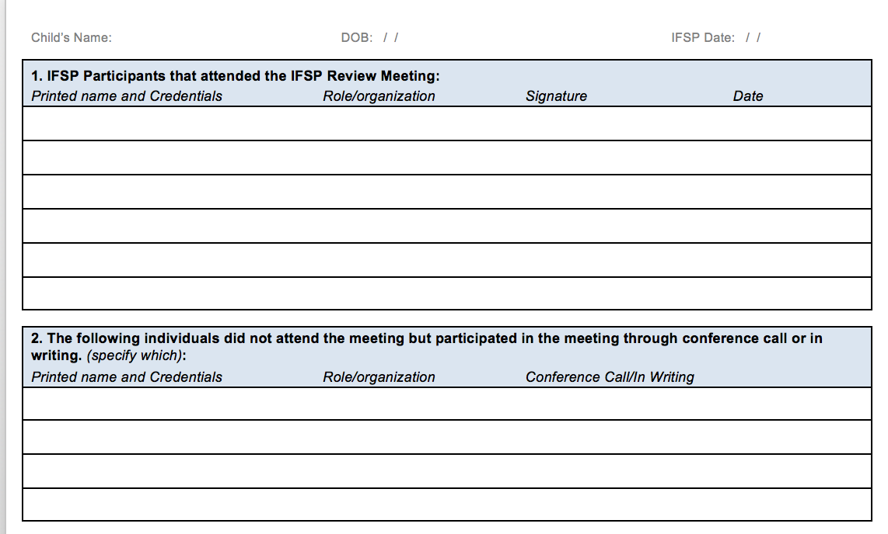
- Providers supporting child and giving input

How do you know you are using the right login?
- If the login ends with an “a” then that is an admin/data manager login.
i.e. ks08a
- If the login ends with a number then that is a IFSP Provider login
i.e. ks0801
- No one should be using login’s ending with anything else
i.e. ks08u

Step 1: IFSP users click on the child’s name to highlight it, and then click the view button.

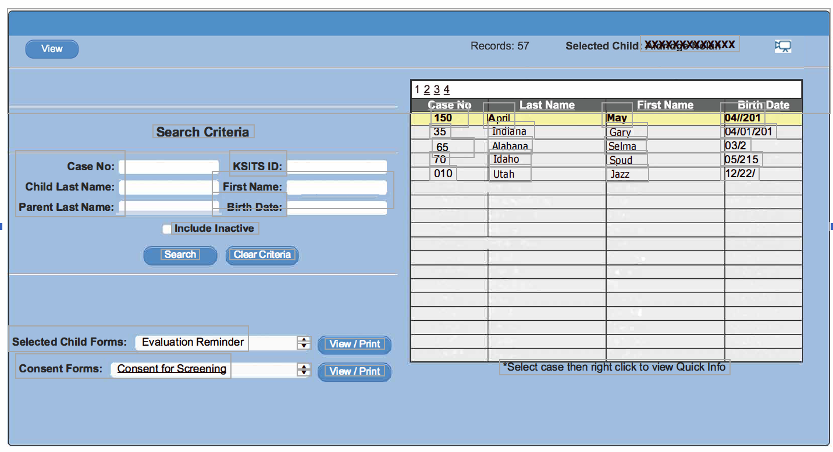

Step 2: IFSP User: Find the IFSP in the list to be reviewed. Select the icon indicated. Hovering over this icon will produce a pop-up that says “Create Review”.

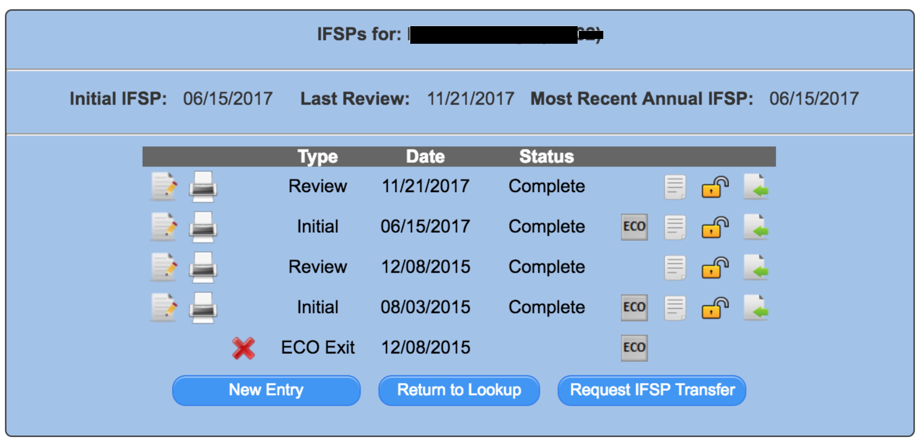

Step 1: Admin/Data manager users select the child to view, and then click on the IFSP/ECO tab.

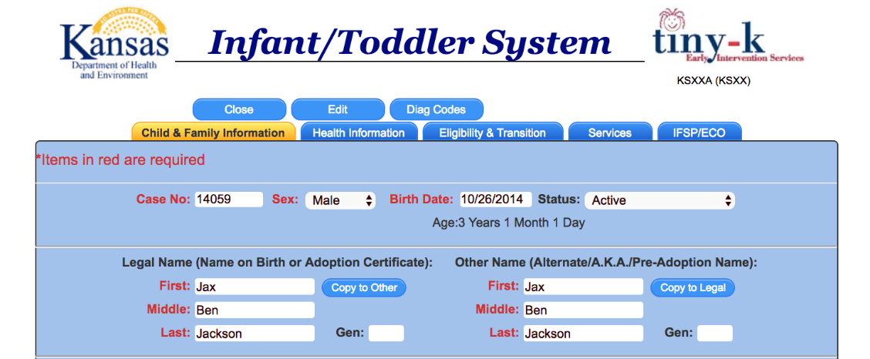

Step 2: Admin / Data Manger User: Find the IFSP in the list to be reviewed. Select the icon
indicated. Hovering over this icon will produce a pop-up that says “Create Review”.

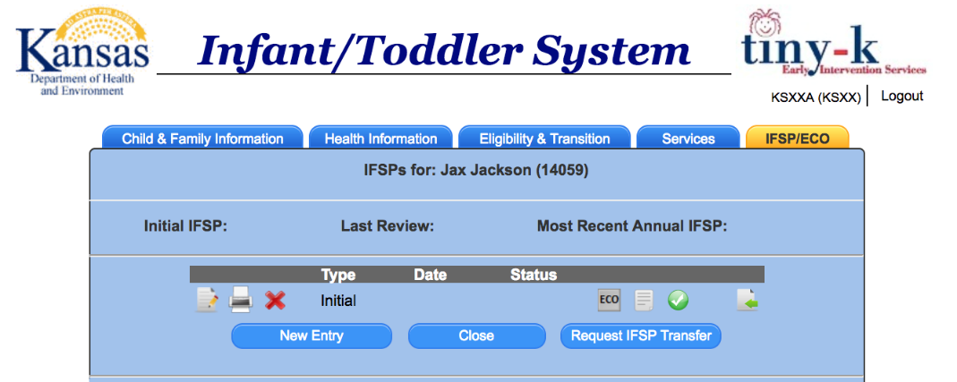
DO NOT USE THE NEW ENTRY BUTTON TO CREATE A REVIEW. Selecting “New Entry” produces a blank document. None of the existing IFSP information will be imported.

Step 3. Select the type of entry (Review), then click on the Import Now button.

IFSP User View

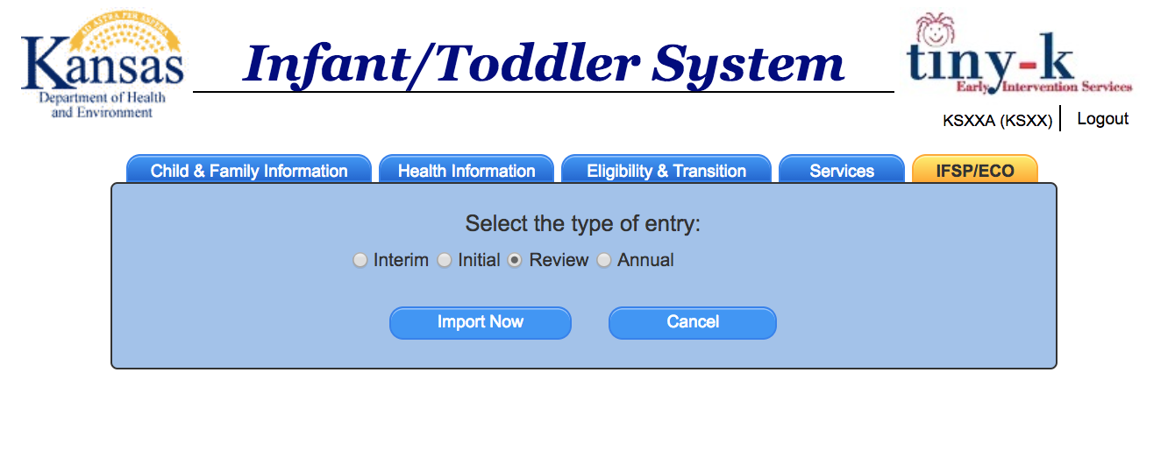
Admin/Data Manager User View

Step 4. Update any page of the IFSP for which there is new information or update the Review Summary Page, including health information; family resources, priorities, and concerns; and my child’s story.

